Botanical Society of Washington – Annual Weekend Excursion

Central Delmarva

August 2 & 3, 2008 (Sat./Sun.)

Bill McAvoy and Larry Morse, Trip Leaders

Final Announcement

As its Annual Weekend Excursion for 2008, the Botanical Society of Washington plans a weekend visit August 2 & 3 to the central portion of the Delmarva Peninsula. A group dinner and overnight accommodations will be offered in or near Seaford near Delaware’s southwestern corner. Bill McAvoy of the Delaware Natural Heritage Program has offered to serve as Saturday’s trip leader, and Larry Morse (Washington, D.C.) will lead Sunday.

Final (revised) itinerary:

Sat. afternoon:
Nanticoke River estuarine wetlands (including seaside alder, Alnus maritima, and an Atlantic white cedar swamp) (Meet at 1:00 pm at the Quality Inn, Seaford, Del.)
Sat. evening
Group dinner and overnight in/near Seaford, Del.
- Jimmy’s Diner, Bridgeport, Del. (7:30 pm)
- Quality Inn, Seaford, Del.
Sun. morning:
Tuckahoe State Park, Md. (Meet at 9:30 am at the Lake Picnic Area, south of Crouse Mill Road)
Picnic lunch at Tuckahoe afterwards (Bring your own)
Sun. afternoon:
Additional habitats in the region, or Adkins Arboretum (nearby)

* * *

Regional map:
http://www.mapquest.com/maps?city=Smithville&state=MD&country=US&latitude=38.773899&longitude=-75.733101&geocode=CITY

Directions. From Washington, Central Delmarva can be reached by taking U.S. 50 east across the Chesapeake Bay Bridge, continuing east on 50 at the 50/301 split after Kent Island, and (for Seaford) turning left onto Md. 404 at Wye Mills, then south on U.S. 13 at Bridgeport. Tuckahoe State Park (Sunday’s destination) is on the north side of Md. 404, west of Md. 313. The driving time from D.C. to Seaford is about 2 hours, if the Bay Bridge traffic is flowing freely.

Terrain generally flat, with water at or near the surface in many places. Wear ankle-high boots or mud-tolerant shoes.

Restaurant:
Jimmy’s Diner
Bridgeport, Del.
(On combined U.S.13 & Del. 404)

Motel:
Quality Inn
225 N. Dual Hwy
Seaford, Del. 19973
Phone: 302-629-8385

For further information, contact BSW trip coordinator Pat Ford at (703)-519-3042 or p2zamora@att.net.

Carpooling. If you would like a ride, or can take riders, contact Pat Ford.

Bay Bridge caution. Consider beach-traffic patterns if using the Chesapeake Bay Bridge: William Preston Lane Jr. Memorial Bay Bridge - Best Times To Travel

Botanical Society of Washington field trips are open to the interested public. ‘

* * *

For the BSW’s 2008 Delmarva visit, Bill McAvoy and Larry Morse have selected two choice but representative contrasting sites for the first two segments of our visit (Saturday afternoon and Sunday morning):

Nanticoke River estuarine wetlands. The Nanticoke’s extensive freshwater-tidal wetlands (photo below) extend upstream to the Seaford area of southwestern Delaware. Habitats include freshwater-tidal swamps, marshes, and firmer shores. The fall-flowering seaside alder (Alnus maritima), a globally rare species (photo), is locally abundant in many places along the Nanticoke and its tributaries. We plan to visit two or three Nanticoke sites, including an Atlantic white cedar swamp, and expect to see Alnus maritima.

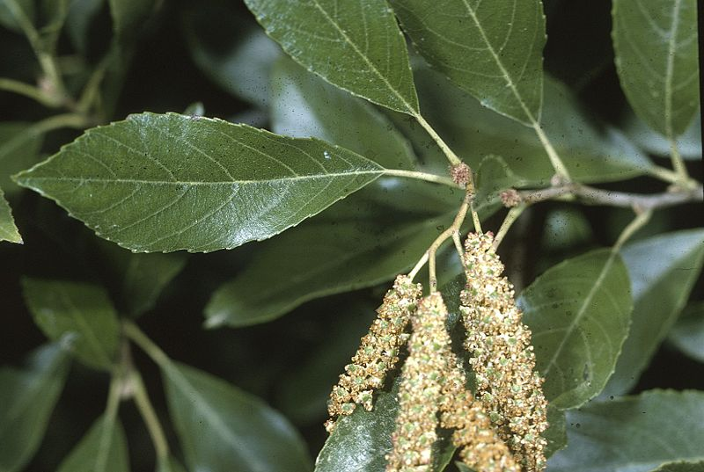
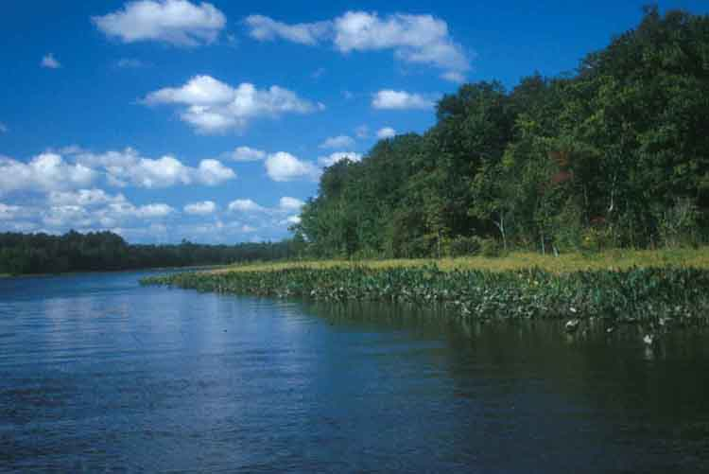

Additional background:
- Nanticoke WMA
- Infraspecific systematics of Alnus maritima (Betulaceae) from three widely disjunct provenances | Castanea | Find Articles at BNET.com
- Resistance to salinity of Alnus maritima from disjunct wetlands: Symptoms of salt injury, comparison to other shrubs, and effect of inundation

- Tuckahoe State Park. The park’s 3800 acres along Tuckahoe Creek include substantial areas of mature forest, both swamp (photo) and upland.
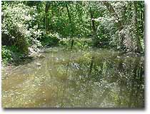
Park map (Md. 404 to south):
http://www.dnr.state.md.us/publiclands/maps/tuckahoemap.html

On Sunday afternoon, we expect to visit one or two additional places, to be selected later. Possibilities include the bald cypresses and other aquatic plants of successional millponds such as Trap Pond, or the flora of relict upland sand deposits. Participants interested in seeing particular habitats, species, or places on Sunday afternoon should contact the organizer (Pat Ford).

* * *

The Delmarva (Del-Mar-Va) Peninsula includes most of Delaware, plus the portions of Maryland and Virginia east of Chesapeake Bay. “Central Delmarva,” between the bayshore and seacoast areas, offers upland, lowland, and freshwater-intertidal riparian habitats in a mostly agricultural Outer Coastal Plain landscape. Major rivers include the Choptank, Nanticoke, Wicomico, and Pocomoke, all wide and slow-flowing, with extensive freshwater-tidal swamps, marshes, and firmer shores. Topography is subtle, with the mostly cleared uplands appearing essentially flat. The maximum elevation is less than 150 feet, and cliffs and bluffs are rare. Due to the area’s location between Chesapeake Bay and the Atlantic Ocean, the climate is mild for the latitude.

The Delmarva flora is noticeably more southern in affinity than that of the Washington, D.C., area. Common trees include loblolly pine, bald cypress, beech, tuliptree, and southern red oak. Most of the uplands are now agricultural, often with large drainage ditches.

Several globally rare plants are known from Central Delmarva, with some having a substantial portion of their total ranges in this area. One of these, Nuttall’s mudwort (Micranthemum micranthemoides), is possibly extinct, last seen anywhere Sept. 13, 1941, but obscure and still worth searching. It was known from freshwater tidal shores of the Choptank, Wicomico, and Pocomoke, although never reported from the Nanticoke. Another, the seaside alder (Alnus maritima), is locally abundant along much of the Nanticoke, with thousands of plants along some shores. This upright, fall-flowering alder is also known along several other Delmarva creeks and rivers, as well as two perennial streams in Oklahoma and a recently discovered site in Georgia.

* * *

In a comparison of the native flora of Central Delmarva with that of the D.C. area (by Larry Morse, using draft data by John Kartesz), eight families, 54 genera, and 241 species were recorded from Sussex Co., Del., and/or Caroline, Dorchester, Queen Anne’s, Somerset, Talbot, Wicomico, or Worchester counties, Md., but not from D.C. or any of the five adjacent counties. Examples include:

- Trees & shrubs: Leucothoe axillaris, Nyssa biflora, Persea palustris, Sideroxylon (Bumelia) lycioides, and Symplocos tinctoria.

- Wildflowers: Bacopa innominata, Cleistes divaricata, Coreopsis rosea, Drosera capillaris, Eupatorium resinosum, Gentiana autumnalis, Lachnanthes caroliniana, Lobelia boykinii, L. canbyi, Lophiola aurea, Narthecium americanum, Oxypolis canbyi, Packera (Senecio) tomentosa, Pycnanthemum setosum, Rhexia aristosa, Sabatia difformis, Sarracenia purpurea, Schwalbea americana, Spiranthes odorata, Trifolium carolinianum, Trillium pusillum, Viola brittoniana, Xerophyllum asphodeloides, Xyris fimbriata, X. smalliana, and Zephyranthes atamasca.

- Grasses: Andropogon glomeratus, Axonopus furcatus, Danthonia sericea, Dichanthelium (Panicum) hirstii, Elymus virginicus, Eragrostis refracta, Gymnopogon brevifolius, Muhlenbergia torreyana, Panicum hemitomon, and P. rigidulum.

- Other species: Fimbristylis perpusilla, Isoetes tenella, Juncus repens, Rhynchospora knieskernii, Schizaea pusilla, and Utricularia resupinata.

Since the Kartesz data used here address entire counties, including any coastal or bayshore habitats, and also include historical records, the number of extant, different native plants in Central Delmarva itself is lower, but still substantial. Of course, many of these species are quite localized, and seasonal considerations apply to some as well, so numerous field days would be needed to see them all. Nevertheless, by visiting several nearby but strongly contrasting habitats, a good number of Delmarva’s distinctive plants can be found in a day or two.

* * *

Other nearby sites. For those considering a longer trip, the following Central Delmarva natural or historical sites may be of interest, in addition to bayshore and seabeach areas:

- Adkins Arboretum. Near Tuckahoe State Park:
Adkins Arboretum on Maryland's Eastern Shore
- Berlin. Historic district.
- Great Cypress Swamp. Crossed by Del. Route 26 east of Laurel, now mostly hardwoods, since few cypresses returned after cutting.
- Martinak State Park. Choptank River riparian, near Denton.
- Milburn Landing, Pocomoke State Forest. West bank of Pocomoke River north of Pocomoke City; cypress along river, mature loblolly, nature trail:
Pocomoke River State Park
Pocomoke River State Forest and Park Trail Guide
- Mason-Dixon First Stone. SW corner of Delaware, surveying markers.
- Snow Hill. Canoe rentals, Pocomoke River:
http://www.atbeach.com/amuse/md/canoe/highlights.asp
- Trap Pond. Large successional millpond with emergent cypress trees and many cypress knees.
- Woodland Ferry. Car ferry across the Nanticoke between Federalsburg and Seaford; easy access to freshwater-intertidal shore vegetation on east bank. (Closed 2008)
- Wye Mills. Operating colonial mill with millpond, park with site and remaining stump of the Wye Oak (was largest white oak).
Most of the above should be shown on a good road map.

-- LEM/23May08, rev. 25July08

